**ALIENS HAVE LANDED**

| Deepanshi | 456807 |
| --- | --- |

**Bow Valley College**

MGMT1103: Essential Skills for Teams Collaboration

Instructor: Hitesh Malik

March 6, 2024.

**INTRODUCTION**

Aliens have landed and it is hard for them to recognize the things and places in Calgary. So, here are some famous places and things about Calgary such as Calgary Tower, Calgary Flames, Rocky Mountain, the most famous river Bow River, Central Public Library, and last but not least Chinatown. They are famous because of their specialties and tallness in the city.

1. **CALGARY TOWER**

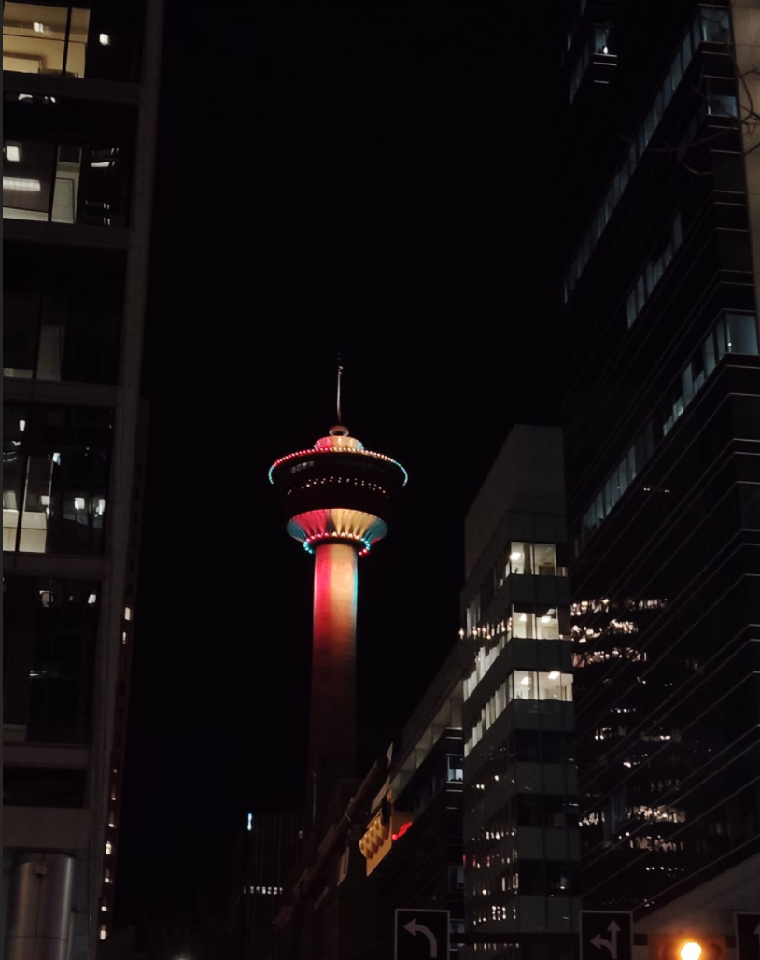

Calgary Tower the “Heart of the #YYC” is located in the center of the city and rises 191 meters above the downtown core, it offers the best view of the city, especially from the Observation Deck, where you'll experience a spectacular 360° view of the city, the majestic Rocky Mountains, the foothills, and the prairies.

1. **CALGARY FLAMES**



The professional ice hockey team based in Calgary is known as “The Calgary Flames”. The symbol depicted in the picture is the team’s emblem. Many fans of ice hockey wear red jerseys featuring flaming C on them when attending an event to show their love and support for the team. Choosing this one as a symbol because it is they are the third major professional ice hockey team to represent the city of Calgary.

1. **BOW RIVER**

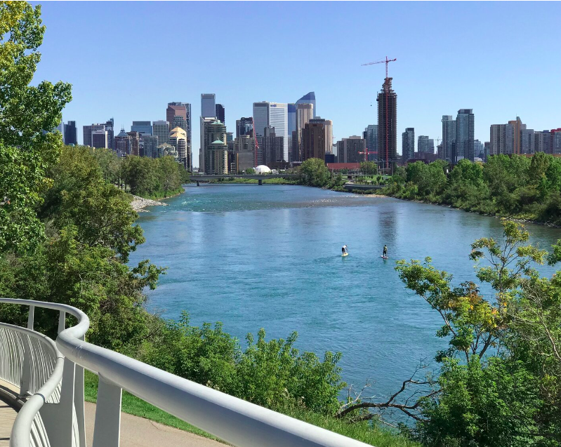

Between 1910 and 1960, the Bow River and its smaller streams underwent engineering to generate hydroelectric power, primarily to serve Calgary's needs. Indigenous peoples utilized the river valleys for buffalo hunts, driving herds over cliffs or into valleys for easier killing using bows and arrows. Among the First Nations residing in the Bow River region, only the Nakoda engaged in regular river fishing. While other groups may have fished during lean periods, their main focus during the abundant summer season was buffalo hunting.

1. **CALGARY PUBLIC LIBRARY**

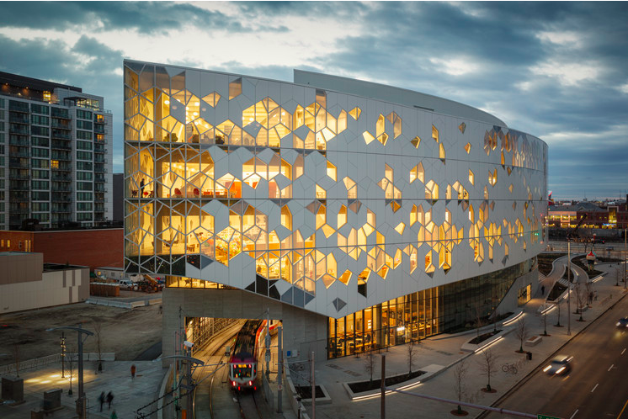

The Calgary Public Library (CPL) is a network of 21 branch locations, including the Central Library. It ranks as the second most utilized system in Canada (following the Toronto Public Library) and North America's sixth most utilized one as of 2012. On the Teen Centre floor, I observed high school students engaged in reading, playing board games, and gaming on large screens within a spacious area. This level is equipped with various technologies, such as video conferencing facilities, audio and video production studios, and a learning center to assist immigrants in settling and adjusting to their new environment.

1. **CHINA TOWN**

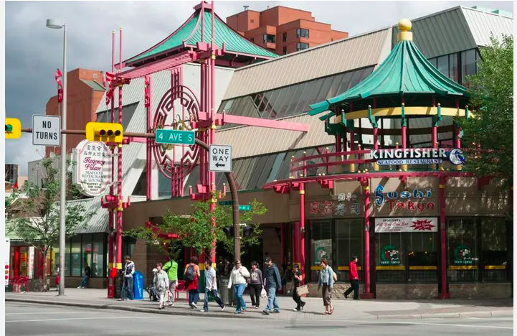 Chinatown stands out as one of Calgary's most culturally unique districts, serving as a focal point between Centre Street North and downtown, offering a rich tapestry of cultural encounters. Over a century across three different sites, Chinatown has evolved, reflecting tales of migration, settlement, and resilience. Today, it remains a bustling center of Asian culture, fostering language, education, community, and commerce within its vibrant community.

This town is famous for:-

* Food and drinks
* Events and Culture
* Public art and outdoor spaces

**Reference**

1. Calgary tower. (n.d). About Calgary Tower. Managed by Aspen Properties, from <https://www.calgarytower.com/about>
2. Wikipedia. (n.d). Calgary Flames. Retrieved by 5th March 2024, from [https://en.wikipedia.org/wiki/Calgary_Flame](https://en.wikipedia.org/wiki/Calgary_Flames)
3. Wikipedia. (n.d). Bow River. Retrieved by 10th July 2023, from <https://en.wikipedia.org/wiki/Bow_River#:~:text=The%20river%20is%20an%20important,power%2C%20primarily%20for%20Calgary's%20use>.
4. Withrow B. 29 February 2020. This Beautiful Modern Library is for Fans of Shiny Things, from <https://www.thedailybeast.com/calgary-central-library-is-one-of-the-worlds-most-beautiful-libraries#:~:text=Calgary%20Central%20Library%20is%20One%20of%20the%20World's%20Most%20Beautiful%20Libraries>
5. Calgary.ca. (n.d). Chinatown, from <https://www.calgary.ca/major-projects/experience-chinatown.html#:~:text=Chinatown%20is%20famous%20for%20its,showcase%20Asian%20culture%20and%20history>.\
6. Wikipedia. (n.d). Calgary Public Library. Retrieved by 24th august 2023, from <https://en.wikipedia.org/wiki/Calgary_Public_Library#:~:text=The%20Calgary%20Public%20Library%20>

# 